**RACHILDE (Marguerite Eymery Vallette) (1860-1953)**

Known mainly for her prose fiction of the Decadent period, the French writer Rachilde contributed to modernist theatre in a number of ways. She was an important figure in French symbolist theatres of the 1890s (particularly Paul Fort's Théâtre d'art and Aurélien Lugné-Poe's Théâtre de l'oeuvre). She had several of her own plays produced, and came into contact with artist groups such as the Nabis (Paul Gauguin designed the program for her 1891 play *Madame La Mort*). The symbolists introduced Scandinavian dramatists such as Henrik Ibsen and August Strindberg to French audiences, and Rachilde's plays were exported to countries such as Denmark. Rachilde also played a central role in getting Alfred Jarry's play *Ubu roi* accepted and performed in 1896.

Rachilde's own work contributed significantly to the development of modernism. In novels such as *Monsieur Vénus* (1884), she foregrounded experimentation with gender roles and raised questions about sexuality. Her plays, while short, deal with the fragmentation of identity (*L'araignée de cristal*, 1894) and conceptual art (*Le vendeur du soleil*, 1894*)*. Her most innovative work dates from the last two decades of the nineteenth century, but she continued writing into the 1930s and 40s, and while her reputation declined, some of her later work (including plays) merits reconsideration in light of modern preoccupations.

**List of Works**

Rachilde. (1998) *Madame la Mort and Other Plays*, trans. and ed. Kiki Gounaridou and Frazer Lively. Baltimore: Johns Hopkins University Press.

------ (1884; 2004) *Monsieur Vénus: A Materialist Novel*, trans. Melanie Hawthorne, MLA Texts & Translations, New York: Modern Language Association.

**References and Further Reading**

Deák, František. (1993) *Symbolist Theater: The Formation of an Avant-Garde*, Baltimore: Johns Hopkins University Press.

Hawthorne, Melanie. (2001) *Rachilde and French Women's Authorship: From Decadence to Modernism*, Lincoln: University of Nebraska Press.

Holmes, Diana. (2001) *Rachilde: Decadence, Gender and the Woman Writer*, Oxford: Berg Publishers.

Kelly, Katherine E. (1996) *Modern Drama by Women 1880s-1930s: An International Anthology*, New York: Routledge.

Robichez, Jacques. (1957) *Le symbolisme au théâtre: Lugné-Poe et les débuts de l'Oeuvre*,Paris: L'Arche.

**Melanie Hawthorne, Texas A&M University**

**Recommended Illustrations**

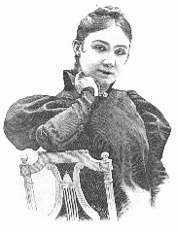

**Rachilde**

[Available at: http://en.wikipedia.org/wiki/File:Rachilde_%28Marguerite_Eymery%29.jpg]

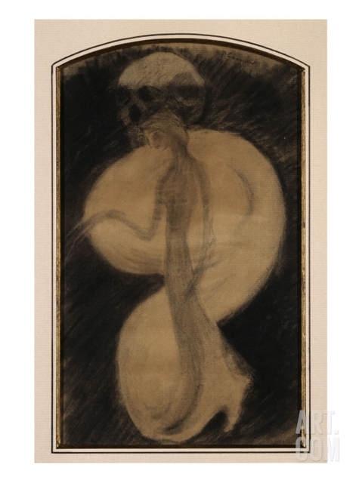

**Illustration by Paul Gauguin for the program of Rachilde's play *Madame La Mort*.**

[This image is in the Louvre and is available at the following site: http://www.art.com/products/p8112102250-sa-i5192582/paul-gauguin-madame-la-mort.htm]